The Odds Of You Being Alive Are Incredibly Small
Dina Spector
Jun 11, 2012, 11:29 AM

It turns out the chances of you existing are infinitely tiny. But just how small?
Dr. Ali Binazir illustrates the extremely unlikely chain of events that would have to occur in order for you to be born with this example in a blog post:
Imagine there was one life preserver thrown somewhere in some ocean and there is exactly one turtle in all of these oceans, swimming underwater somewhere. The probability that you came about and exist today is the same as that turtle sticking its head out of the water — in the middle of that life preserver. On one try.
Dr. Binazir has crunched the exact numbers shown in the infographic below.
The path begins with the odds of your dad meeting your mom (1 in 20,000). This is multiplied by the chances of them staying together long enough to have kids (1 in 2,000), and so on...
The probability of you existing at all comes out to 1 in 10^{2,685,000} — yes, that's a 10 followed by 2,685,000 zeroes!
Binazir concludes that the odds of you being alive are basically zero.

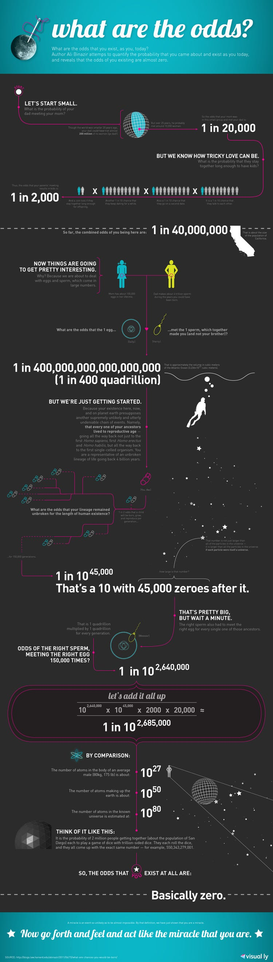visual.l

